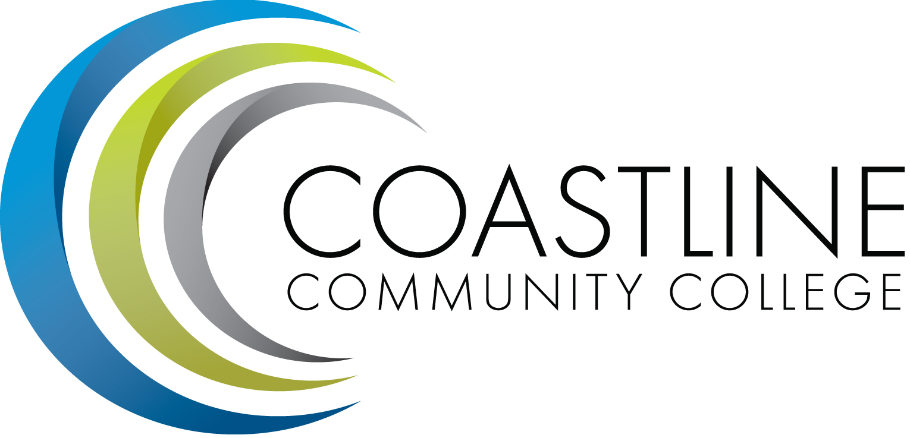
Coastline Management Meeting (CMT) Agenda
February 6, 2018, 9:00 – 11:00 a.m.
College Center – 4th Floor Conference Room

Committee Mandate: To review and improve College operations and management through sharing information, discussion, and staff development.

CALL TO ORDER
  - Welcome
  - Adoption of Agenda
  - *Approval of Minutes – January 16, 2018

OPEN SESSION SPECIAL REPORTS & UPDATES (15 minutes per)
  - Agenda Format Draft Template – D. Thompson
  - Committee Member Expectations Draft – A. Zentner
  - CalFresh / Food Pantry – J. Mendez
  - *Upcoming A2I2 Guided Pathways Visits – L. Adrian, A. Zentner

REPORTS (5 minutes per)
  - Presidents Update (Cabinet)
  - Regulatory Items
    - Accreditation
    - HR
    - Institutional Effectiveness
    - Budget
  - Academic Senate
  - Classified Senate
  - ASG

OPEN SESSION ANNOUNCEMENTS & DISCUSSION (5 minutes per)
  - Flex Day Activity – S. Blair, A. Zentner
MOVE TO CLOSED SESSION
- ACTION ITEMS (15-30 minutes)
  - Guided Pathways Themes – Discussion Guide Follow-Up

- PROFESSIONAL DEVELOPMENT (30 minutes)
  - Retreat Planning/Professional Development Day Planning
    - Appreciative Inquiry
    - Emotional Intelligence
    - Planning for 2018-19

- CLOSED SESSION ANNOUNCEMENTS & DISCUSSION (5 minutes per)
  - Familiarization with the *Integrated Planning Guide/Ideas for Providing Information to Others – A. Zentner

- ADJOURNMENT
*Attachment
Next Meeting: March 6, 2018

For next meeting:
District Wide Strategic Plan 2014-17 – Andrea Serban, Vice Chancellor, Educational Services and Technology

